Experiment 1: Student Performance Analysis Using NumPy
AIM
To calculate the average score of each subject using NumPy arrays and identify the subject with the highest average score.
ALGORITHM
- Import the NumPy library.
- Create a 4 × 4 array containing student marks.
- Arrange the subjects in the order: Math, Science, English, History.
- Calculate the average of each column using np.mean() with axis=0.
- Find the highest average using np.argmax().
- Display the average score of each subject.
- Display the subject having the highest average score.
CODE
import numpy as np
student_scores = np.array([
[85, 78, 92, 88],
[90, 85, 89, 76],
[75, 80, 85, 90],
[88, 92, 78, 84]
])
subjects = ["Math", "Science", "English", "History"]
subject_averages = np.mean(student_scores, axis=0)
print("Average score for each subject:")
for subject, avg in zip(subjects, subject_averages):
print(subject, ":", avg)
highest_index = np.argmax(subject_averages)
print("\nSubject with highest average score:",
subjects[highest_index])

INPUT
Student marks:
Math Science English History
85 78 92 88
90 85 89 76
75 80 85 90
88 92 78 84
OUTPUT
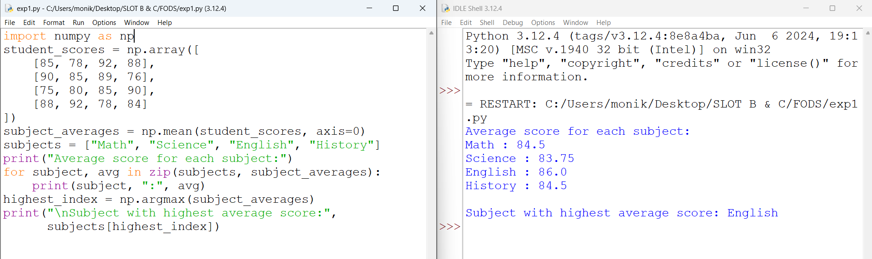
RESULT
Thus, the average score for each subject was calculated successfully using NumPy, and English was identified as the subject with the highest average score.

